## Database Introduction

### Goal of DBMS

Reduce application development time

Concurrency (protect data from inconsistency) and Recovery through

1. file and access methods

2. buffer management

3. disk space management and I/O manager (data files, index files, catalog fies)

Security and access control

### Terminology

data model = collection of concepts for describing data

schema = description of a particular collection of data

relational model consists of relation and schema

DDL (data definition language) used to express views + logical schemas

DML (data manipulation language) used to access/update the data

QL (query language) = DML or for its retrieval sublanguage

DBA (database administrator)

### Level of DB With examples

views = how different users see the data

CourseInfo(cid, cname, pid)

conceptual schema = logical structure of the DB

professor(pid:string, name:string)

courses(cid, name)

physical schema = files/indexes used

### Data Independence

logical DI = protection from changes in logical structure

physical DI = … in physical structure

### Components’ roles

query parser parse and analyze SQL query and make sure the query is valid

query optimizer finds a good query plan by rewriting the query logically and performing cost-based optimization

relational algebra

## Logical Database

### Definitions

Entity (real object) is described using a set of attributes

Entity Set = a collection of similar entities.

Each entity set has a key (unique ID)

Each entity attribute has a domain (data type)

Relationship Set = collection of relationships in a same type

### ER Diagram

Cardinality constraints (1-N relationship) M:N is default if omitted

**boldness** means the it’s mandatory

Ex. Professor —1—<head> —N— Department means department has exactly one professor head but professor can be the head of many departments

Create Table head(

pid CHAR(11),

did INTEGER,

Primary Key (did),

Foreign key (pid) References Professor,

Foreign key (did) References Department

)

Create Table Department2(

did INTEGER,...,

head_pid CHAR(11)

Primary Key (did),

Foreign key (pid) References Professor

)

Ex. between Employees and Reports_to

—supervisor 1 —

—subordinate N—

Ex binary RS: student — <enroll_in> — courses

Weak Entity = identified uniquely only by considering the primary key of some other entity

Owner entity and weak entity must participate in a one-to-many relationship

Weak entity must have total participation in this identifying relationship set (delete owner entity will delete weak entity)

Dependent identifier is unique only within the owner context. Primary key is (owner_key, weak_key)

Ex Employee —1—<< Policy>> —N—Dependents

Ternary Relationship: relationship key <= entity keys

Patient —M— Prescribe —1—Doctor

|

N

|

Drug

A given patient + drug will be given by only one doctor(1)

A given patient + doctor may associated with several drugs(N)

A given doctor + drug may be associated with several patients(M)

### IsA hierarchy

ER attributes, including key, are inherited

Covering constraints: B and C inherits A with covering => every A is either B or C

Overlap constraints: … with overlap => A can be B or C or both (B (not disjoint from) C)

Disjoint = if or not the subtypes are disjoint from one another (no overlap between subclass)

### Aggregation

allows us to treat a relationship as an entity to participate in (other) relationships

Aggregation: the aggregated relationship are independent from the outside entity

Ternary relationship: the “aggregated” relationship are dependent on outside entity

### More advanced

Multi-valued attributes: doubled circle

ex. [person] — ((phones))

Create Table Person_phones(ssn, phone) with multiple rows for the same ssn

Composite attributes: attributes has multiple attributes (sub attributes can be mandatory)

ex. a person has an address which consists of street, city, zip…

Create Person(ssn, address_street, address_city, address_zip)

Mandatory attributes: node between entity to attribute at the attribute end

ex. every person must have a name [person] —**\*** (name)

Create Table Person (name varchar(20) NOT NULL)

Derived (vs. stored) attributes: dashed circle

ex. employee’s age will change, so we store their date of birth and update accordingly

Create View age(ssn) As Select (TodayDate() - e.BirthDate()).ToYear() From Employee e Where e.ssn = ssn

Ternary Relationship can be translated to an entity with three relationships to the other three entities

## Relational Database

### Relation 2 Components

Instance = a table with rows and columns. #row = cardinality, #fields = degree or arity

Schema = name of relation + name + type of column

ex. Students (sid:string, name:string)

### Integrity Constraints (ICs)

Def = condition that must be true for any instance (eg. domain constraints)

* ICs are specified when schema is defined
* ICs are checked when relations are modified
* All instances must satisfy a IC for the IC to be true

A legal instance of a relation satisfies all ICs (DBMS should not allow illegal instances)

Types

Primary Key Constraints (unique identifier): superkey, primary key, candidate keys

Foreign Key = Referential Integrity options on modification:

Default = no action (modification is rejected)

CASCADE = references are also modified

SET NULL/DEFAULT = references set to default

Participation Constraints

Ex. Professor —1—<head> **—N—** Department

Create Table Department2(

did INTEGER,...,

head_pid CHAR(11) **NOT NULL**,

Primary Key (did),

Foreign key (pid) References Professor

)

Weak Entities: on delete cascade is usually required

Ex. Employees —1—**<Policy> —N— Dependents**

Create table Dependents2(

dname VARCHAR(20),

eid INTEGER **NOT NULL**,

**PRIMARY KEY (dname, eid)**,

FOREIGN KEY (eid) REFERENCES Employees ON DELETE CASCADE ON UPDATE SET DEFAULT

)

IsA Hierarchies

Ex. Hourly Emps & contract_Emps –IsA (covering not disjoint) — Employees

Ways to implement:

1. Recommended Delta 3 relations:

How:

Employees (all employees partially reside), Hourly_Emps, Contract_Emps

Subtables will have FK to Parent table

Unique information on each table, common key value for join

Costly if frequently access the children with parent attributes

Good for maintaining PK uniqueness, FK references

1. Union of table:

Employees (only Employees), Hourly_Emps & Contract_Emps

Redundant data of overlapping instances, okay for disjoint tables

For all employees queries, it needs to union all three tables

Bad for PK uniqueness (it needs to check all three tables), FK references

For covering constraints, the only-employee should not exist

1. Mashup table:

How:

Emps(kind, common_attibutes, children_attributes)

All in the same table with “kind” ENUM specifying its type

Bit as kind to check its type

Many missing values

Good PK uniqueness, FK reference

Views on top of the big mashup table to only show hourly or contract employees.

How to choose

Expected queries? frequent queries?

PK/unique constraints? FKs?

Space/time tradeoff?

SQL Views

Views is used for derived attributes, simplifying/eliminating join paths, beautifying “Mashup table”

* CHAR padded with extra spaces and VARCHAR padded without extra spaces
* For 1 to N relationship, the relation table can be integrated to one of the entity (N end)

space and time efficiency (save time of joining tables)

ex. ER Diagram > Cardinality > first example

10/5 Lecture: how to convert ER to tables with weak entity and 1 to N relationship

## Relational Design Theory

### Functional Dependencies(FD)

Functional Dependencies used for other context and SQL query optimization

If queries are all retrieving one feature, it might be good to divide into smaller table?

Why?

helps identifying problem schema

Redundancy costs extra storage and time to insert/delete/update

How?

main tool = decomposition

ex. replace R(ABCD) with R1(AB)+R(BCD)

* One fact, one place – good rule to follow

Def: X depends Y (X → Y) holds R for all instances:

t1 and t2 in R, t1.X = t2.X implies t1.Y=t2.Y (X and Y can be attributes)

* If only look at one instance, only able to verify conflict/violates

K = candidate key for R means K → R

K → R doesn’t mean K is minimal or is the key. If K is minimal, then K is a candidate key (else superkey)

superkey may contain extra information, candidate key is the minimal superkey

ssn → id, id → name, did → dname

(ssn, did) is the candidate key but (ssn, id, did) is a superkey

ex. HourlyEmps(ssn, name, lot, rating, hrly_wage, hrs_worked)

set = {SNLRWH)

ssn is the key: S → SNLRWH

rating determines wage: R → W

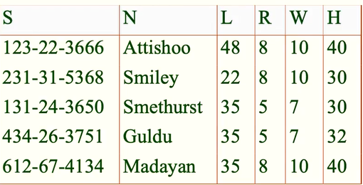

update anomaly: change 1st row’s W

insertion anomaly: insert a new row with 6 R => doesn’t know the W for 6 R

deletion anomaly: delete all rows with 8 rating => lose

closure of $F^{+}=set of all FDs that are implied by F$

Armstrong’s Axioms

Reflexivity: $if X⊆Y (X is subset of Y), then Y-> X$

Augmentation: $if X -> Y, then XZ -> YZ for any Z$

Transitivity: $if X -> Y and Y -> Z, then X -> Z$

Union: $if X -> Y and X->Z, then X->YZ$

Decomposition: $if X->YZ, then X->Y and X->Z$

Partial: $XY is key, X ->Z$

ex. Contracts(cid, sellerId, projectId, departmentId, partId, qty, value)

1. contract id is the key: C → CSJDPQV
2. a project purchases each part using single contract: JP → C
3. a dept purchases at most one part from a supplier: SD → P

Then: by (1) + (2) => JP → CSJDPQV (JP is the candidate key)

by (3) => SDJ → JP => SDJ is the candidate key

ex. R(ABCDE), F={A→B, B→C, CD→E}

AD→BD→CD→E, then AD → ABCDE, so AD is candidate key

Efficient way to check

Compute attribute closure of X (X+)

Check if Y is in X+

Ex. F={A→B, B→C, CD→E} imply A → E?

(Is A→E in F+) is the same as (Is E in A+)

FDs & Redundancy

for R(ABC), no FDs hold => no redundancy

### Normal forms

1NF = flat (if all attributes are atomic)

X is prime attribute if X is part of (candidate) key

X is a superkey if X contains a candidate key

2NF = 1NF + NO non-key attribute is partially dependent on a candidate key

Ex. Supplies(sno, sname, saddr, pno, pname, pcolor)

sno → sname, sno →saddr, pno → pname, pno → pcolor

candidate key: sno+pno

prime attributes: sno, pno

Not a 2NF because sname, saddr, pname, and pcolor are partially dependent on a candidate key sno, or pno

3NF = 2NF + no transitive dependencies to non-prime attributes

Ex. Workers(eno, ename, esal, dno, dname, dfloor)

eno→ename, eno→esal, eno→dno, dno→dname, dno→dfloor

candidate key: eno

prime attributes: eno

Not a 3NF because transitive dependencies on dno

* good stop point because breaking down more will result more join. A lossless-join

BCNF (no non-trivial FDs)

$for all X->A in F^{+}, A∈X(trivial FD) or X is a superkey for R$

R is BCNF if the only non-trivial FDs are key constraints

Ex. Supply2(sno, sname, pno) given sno→sname, sname→sno

candidate key: sno+pno and sname+pno

prime attributes; sno, sname, pno

Is 3NF

Not BCNF because pno is not a key (multiple candidate keys and they overlap)

FIX: Supplier2(sno, sname) + Supplies2(sno, pno)

* not always possible to get BCNF
* no non-trivial FDs means no dependencies between existing attributes and it’s BCNF

### Decomposition of a Relation Schema

Dependency-Preserving Decomposition

Def: every previous FDs has a home (hold on one of the decomposed tables)

Ex. S → SNLRWH, R → W can decompose into SNLRH and RW

Projection of set of FDs F:

R is decomposed into X…, $F_{X}$ (projection of F into X) is set of FDs U → V in F+ where U and V are both in X

How to determine if it’s dependency preserving (R into X, Y):

1. No dependencies in R across X and Y. It’s either in X or Y
2. All dependencies in R can be found in X or Y, which is (Fx union Fy)+ = F+

3 potential issues:

Some join queries can become more expensive

Bad decomposition => lossy (unable to reconstruct original one)

Checking some dependencies may need joining the instances

* Dependency preserving doesn’t imply losslessness

Ex. ABC with A→B is decomposed into AB and C

* Some are not dependency preserving into BCNF

Ex. R(CSZ) with CS → Z and Z → C

Ex. R(CSJDPQV) with JP → C, SD → P, and J → S

not dependency preserving into SDP, JS, CJDQV

could add forth table JPC but redundant

Lossless Join Decomposition

Decompose R into X and Y is lossless-join if 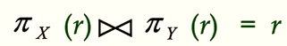

Make sure X and Y overlap and the overlap contains a key for one or two relations

* lossy join usually gives more data than original

## Relational Query Languages

Def

Query language != programming language

allow manipulation of data from a database

Two types

### Relational Algebra (operational)

Selection $σ$

selects rows that satisfy selection condition (filter row)

Ex. S2

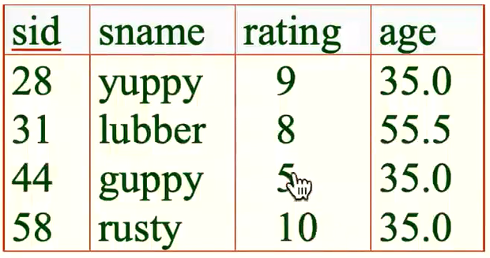

$σ_{rating > 8}(S2)$

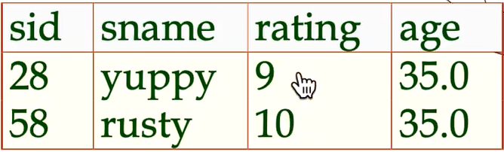

Projection $π$

removes attributes that are not in projection list (filter column)

removes duplicates

Ex. S2



$π_{sname, rating}(S2)$

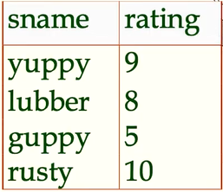

$π_{age}(S2)$

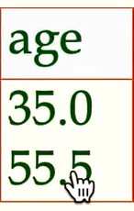

Set-difference $-$ in relation1, but not in relation2

Union $∪$ in relation1 and/or in relation2

same number of fields (same column)

remove duplicates

Ex. S1 and S2

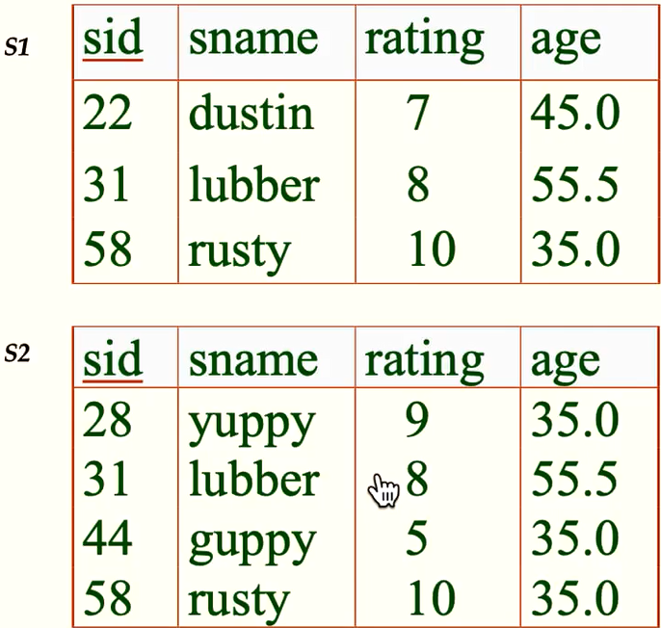

S1 $∪$ S2

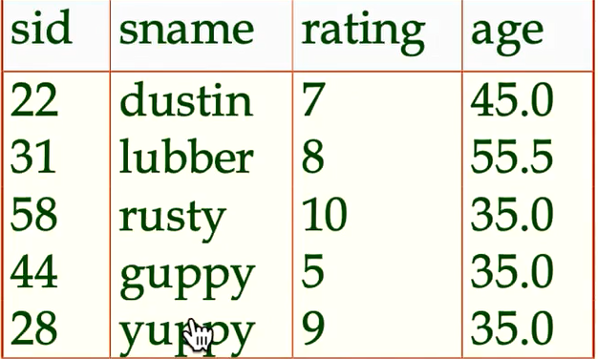

S1 $∩$ S2

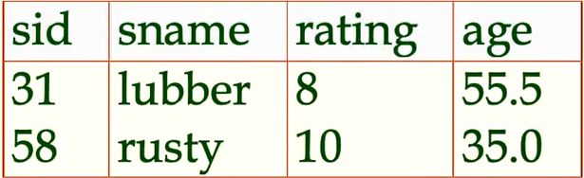

S1 - S2

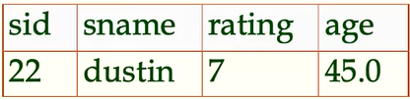

Cross-product $×$ combines two relations

Ex. S1 x R1

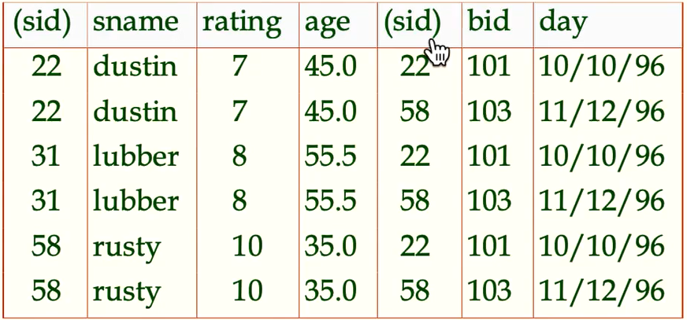

Renaming operator: $ρ(result name(rename list), Source Expression)$

Ex. $ρ(C(1→sid1, 5→sid2), S1×R1)$

${(π}_{sid→sid1,sname,rating,age}(S1))×R1$

Condition Joins (not primitive) 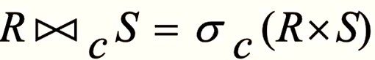

Theta-join: $S1 ∞_{s1.sid < R1.sid} R1$, same fields as the cross-product

Equi-join $S1 ∞_{s1.sid = R1.sid} R1$, only one field of equality + other fields like cross product

Natural join $∞$ an equijoin on all commonly named fields

Outer join (left, right, full)

Division (not a primitive operator)

Table A(x,y) and B(y), A/B contains the x such that for every y is in B

Ex. find sailors who have reserved all boats

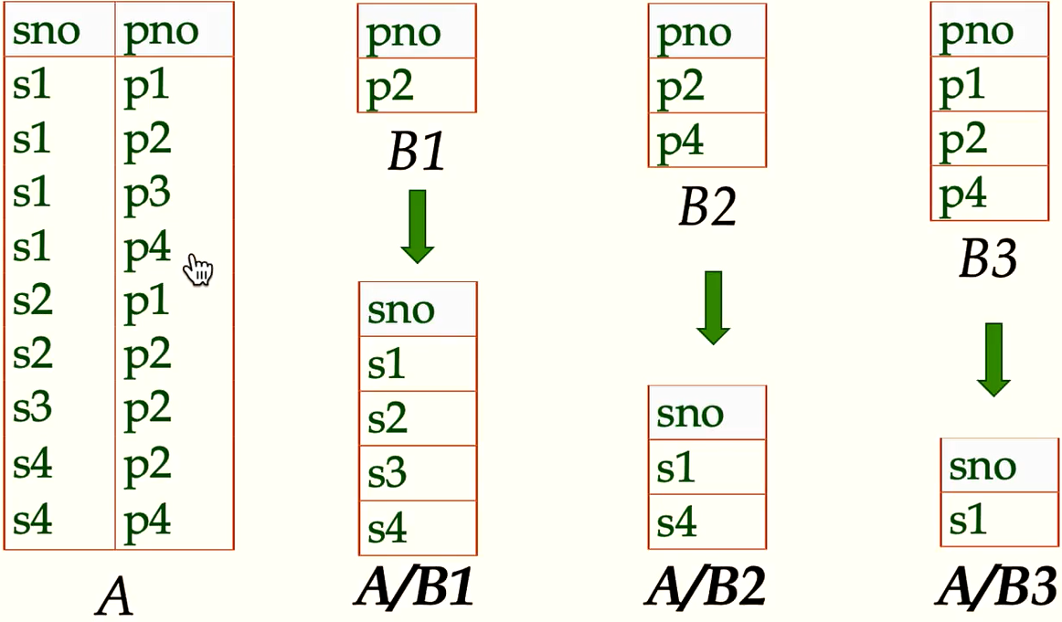

Optional $A/B=π_{x}(A)-π_{x}({ (π}_{x}(A)×B) -A)$

C = x in A * y in B = all combinations of x and y

D = C - A = combinations that are not in A

A/B = A - D = combinations in A

Ordering $=τ age desc (Sailors)$

Grouping $=Υ age, avg(rating)→avgRating(Sailors)$

Ex. For the following three tables;

sailors(sid, snake, rating, age)

reserve(sid, bid, date)

boats(bid, bname, color)

Find names of sailors who’ve reserved boat #103

${π_{sname}(σ}_{bid=103}reserve ∞_{sid = sid} sailors)$

Find names of sailors who’ve reserved a red boat

$π_{sname}(π_{sid}((π_{bid}σ_{color='red'}boats) ∞_{}reserve)∞_{}sailors)$

Find sailors who’ve reserved a red or/and a green boat

${A = π}_{sid}( (π_{bid}σ_{color='red'}boats )∞_{}reserve∪/∩(π_{bid}σ_{color='green'}boats)∞_{}reserve) )$

$π_{sname}(A∞_{}sailors)$

Find names of sailors who’ve reserved all boats

${σ_{sname}(π}_{sid}(reserve/boats) ∞ sailors)$

RelaX renaming



### Relational Calculus (declarative)

relation instances

schemas of input are fixed

schema for result is also fixed

notations

positional notation for formal definitions

named-field notation for more readable

Tuple Relational Calculus

Query in TRC has the form: $\{t(attrlist) | P(t)\}$

includes all tuples t with attrlist that cause formula P(t) to be true

* t on the left of | must be the only free variables of formula P(...)

TRC Formula

Atomic formula: $r ϵ R, or r !ϵ R, or ¬P$

$P⇒Q is equivalent to (¬P)∨Q$

* unsafe queries have an infinite number of answers. Ex. $s | ¬(s ϵ Sailors)$
* every relational algebra can be expressed as a safe query in DRC/TRC. converse is also true
* Relational Completeness = every query is expressible in relational algebra/safe calculus

Free and bound variables

quantifier such as $∃t ϵ T or ∀t ϵ T$ is bound variables, others are free

Ex. For the following three tables;

sailors(sid, snake, rating, age)

reserve(sid, bid, date)

boats(bid, bname, color)

Find sailors with a rating above 7

$\{s | s ϵ Sailors ∧s.rating>7\}$

$=\{t(id,nm,rtg,age) | ∃s ϵ Sailors (s.rating>7∧t.id=s.sid∧t.nm=s.sname∧t.rtg=s.rating...)\}$

Find ids of sailors who are older than 30 or who have a rating under 8 and named ‘Horatio’

$\{t(sid)| ∃s ϵ Sailors ((s.age>30)∨(s.rating<8∧s.sname='Horatio')∧t.sid=s.sid)\}$

Find names of sailors who’ve reserved a red boat (with joins)

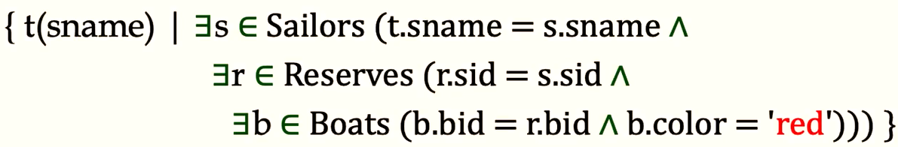

Find sailors who’ve reserved a red or/and a green boat

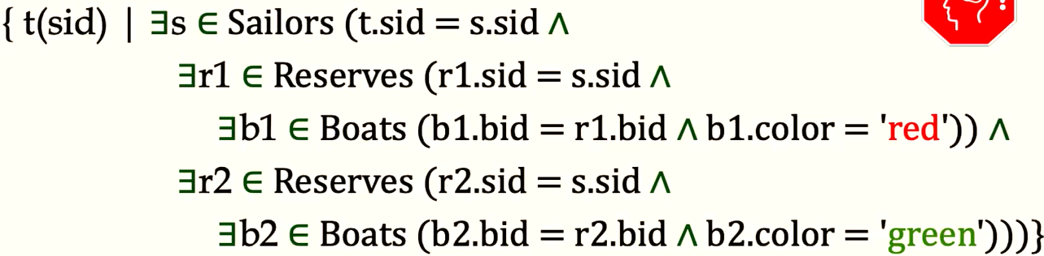

* Cannot use s,r, b1,b2 because 1 reservation only matches 1 boat

Find names of sailors who’ve reserved all boats (universal quantification)

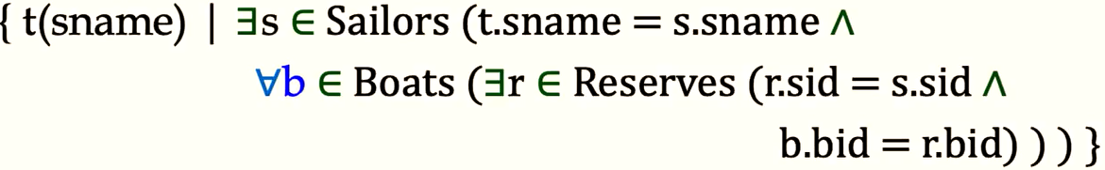

Find the names of sailors who’ve reserved all Interlake boats

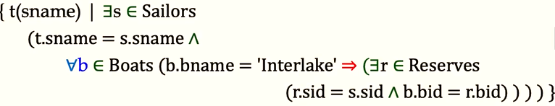

* For all boats, if name is Interlake, then try to validate the rest

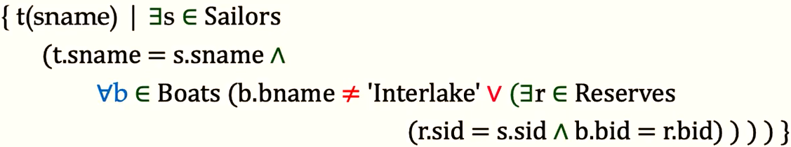

* For all boats, either name is not Interlake or validate the rest

## SQL Basics

SELECT [DISTINCT] target-list $π$

FROM relation-list

WHERE qualification $σ$

\

Expressions and Strings

AS provides a way to rename fields in result

LIKE used for string matching. ‘_’ = any 1 char. ‘%’ = 0 or more arbitrary chars

Ex. For the following three tables;

sailors(sid, snake, rating, age)

reserve(sid, bid, date)

boats(bid, bname, color)

Find sailors who’ve reserved at least one boat

SELECT DISTINCT s.sid

FROM Sailors S, Reserves R

WHERE S.sid = R.rid

* Distinct will not return the duplicate sid if one sailor has multiple reservations

Find sids of sailors who revered a red or green boat

SELECT **DISTINCT** s.sid

FROM Sailors S, Reserves R, Boats B

WHERE S.sid = R.rid AND R.bid = B.bid AND (B.color = ‘red’ OR B.color = ‘green’)

### Union SQL

*Find all sids of sailors who reserved a red boat and a green boat*

(SELECT s.sid

FROM Sailors S, Reserves R, Boats B

WHERE S.sid = R.rid AND R.bid = B.bid AND B.color = ‘red’)

**UNION**

(SELECT s.sid

FROM Sailors S, Reserves R, Boats B

WHERE S.sid = R.rid AND R.bid = B.bid AND B.color = ‘green’)

* UNION removes the duplicates. UNION ALL keeps duplicates
* union-compatible = two tables has same number of fields with same data type/format

### EXCEPT = Set difference

*Find all sids of sailors who reserved a red boat but never reserved a green boat*

(SELECT s.sid

FROM Sailors S, Reserves R, Boats B

WHERE S.sid = R.rid AND R.bid = B.bid AND B.color = ‘red’)

**EXCEPT**

(SELECT s.sid

FROM Sailors S, Reserves R, Boats B

WHERE S.sid = R.rid AND R.bid = B.bid AND B.color = ‘green’)

MySQL and PostgreSQL

MySQL has UNION but not EXCEPT and INTERSECT

Alternative for INTERSECT

*Find all sids of sailors who reserved a red boat and a green boat*

SELECT S.sid

FROM Sailors S, Boats B, Reserves R

WHERE S.sid = R.sid AND R.bid = B.bid AND B.color=’red’

AND S.sid **IN** (SELECT S.sid

FROM Sailors S, Boats B, Reserves R

WHERE S.sid = R.sid AND R.bid = B.bid AND B.color=’green’)

Alternative for EXCEPT will be using **NOT IN**

### Nested Query

*Find name of sailors who’ve reserved boat #103*

SELECT S.sname

FROM Sailor S

WHERE S.sid **IN** (SELECT R.sid FROM Reservers R WHERE R.bid = 103)

SELECT S.sname

FROM Sailors S

WHERE **EXISTS** (SELECT * FROM Reserves R WHERE R.bid = 103 AND S.sid = R.sid)

* query optimizer will optimize by having a temporary table for nested part

More Set-Comparision Operator: ANY, ALL

*Find sailors whose rating is greater than that of some sailor named Horatio*

SELECT *

FROM Sailors S

WHERE S.rating > ANY (SELECT S2.rating FROM Sailors S2 WHERE S2.sname = ‘Horatio’)

### Division

*Find sailors who’ve reserved all boats*

SELECT S.sname

FROM Sailors S

WHERE **NOT EXISTS** (

(SELECT B.bid FROM Boats B)

**EXCEPT**

(SELECT R.bid FROM Reserves R WHERE R.sid = S.sid)

)

OR

SELECT S.sname

FROM Sailors S

WHERE **NOT EXISTS**(

(SELECT B.bid FROM Boats B WHERE **NOT EXISTS** (

SELECT R.bid FROM Reserves R

WHERE R.bid = B.bid AND R.sid = S.sid

))

)

OR

SELECT S.sname

FROM Sailors S

WHERE (SELECT COUNT(DISTINCT R.bid) FROM Reserves R WHERE R.sid = S.sid)

=

(SELECT COUNT(B.bid) FROM Boats B)

### Others

Ordering and/or Limiting Query Results

ORDER BY field_name DESC/ASC [NULLS FIRST]

LIMIT # [OFFSET #] used for paginating

LIMIT 5 OFFSET 2 (get row 3-8 inclusive)

SET search_path TO [schema_name]

## SQL Analytics

### Aggregation

COUNT (*), COUNT/SUM/AVG ( [DISTINCT] A ), MAX/MIN ( A )

Find name and age of the oldest sailor(s)

illegal: SELECT S.sname, MAX(s.age) FROM Sailors S

SELECT S.sname, S.age FROM Sailors S

WHERE S.age = (SELECT MAX(age) FROM Sailors)

### Grouping

Syntax

SELECT [target_list]

FROM [relation_list]

WHERE [qualification]

GROUP BY [grouping_list]

HAVING [grouping_qualification]

* target_list must be a subset of grouping_list
* like where to eliminate some groups. Attribute in grouping_qualification must be argument of aggregate op or must in grouping_list

Find age of youngest sailor with age >= 18 for each rating level with at least 2 such sailors

SELECT S.rating, MIN(S.age)

FROM Sailors S

WHERE S.age >= 18

GROUP BY S.rating

HAVING COUNT(*) > 1

For each red boat, find number of reservations for this boat

SELECT B.bid COUNT(*)

FROM Boats B, Reserves R

WHERE B.bid = R.bid AND B.color = ‘red’

GROUP BY B.bid

* if we want to get the boat name…
  + Some systems requires you to add B.bname to grouping_list
  + Some systems know B.bid is the key, B.bname can be added to target_list without adding to the grouping_list (looking at the FDs)
  + However, if we want to get R.sid in target_list without aggregation operation, we must add it to grouping_list because B.bid cannot determine R.sid. With aggregation operation, we can do things like COUNT(DISTINCT R.sid)
* if we move B.color = ‘red’ in HAVING, we need to GROUP BY B.bid, B.color
  + Some system may require you to add B.color to grouping_list

Find age of youngest sailor with age > 18 for each rating level with at least 2 sailors (of any age)

SELECT S.rating, MIN(S.age)

FROM Sailors S

WHERE S.age > 18

GROUP BY S.rating

HAVING 1 <

(SELECT COUNT(*)

FROM Sailors S2

WHERE S2.rating = S.rating)

Find those ratings and average ages for which the average Sailor age (for that rating group) is the minimum age over all of the Sailors

SELECT Tmp.rating, Tmp.age

FROM

(SELECT S.rating, AVG(S.age)

FROM Sailors S

GROUP BY S.rating) AS Tmp

WHERE Tmp.age = (SELECT MIN(age) FROM Sailors)

OR

WITH Tmp AS (SELECT S.rating, AVG(S.age)

FROM Sailors S

GROUP BY S.rating)

SELECT t.rating, t.age

FROM Tmp t

WHERE t.age = (SELECT MIN(age) FROM Sailors)

### Null

Used when value is unknown or inapplicable

* WHERE clause only returns result if it’s true ⇒, NULL rows are eliminated.
* Boolean operations: true AND unknown = unknown, false AND unknown = false. false OR unknown = unknown. true or unknown = true. NOT unknown = unknown
* For null values, must use IS NULL to evaluate

Aggregation on NULL will eliminate null rows

SELECT COUNT(DISTINCT bid) FROM Reserves ⇒ 4 rows

Grouping on NULL can extra null group

SELECT bid, COUNT(*) FROM Reserves GROUP BY bid ⇒ 5 rows including null row

HAVING bid IS NOT NULL ⇒ 4 rows

### Join

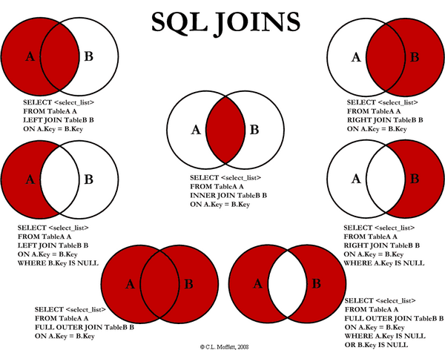

Inner Join eliminates NULL on both sides (default join)

SELECT DISTINCT s.sname, r.date

FROM Sailors s, Reserves r

WHERE s.sid = r.sid

SELECT DISTINCT s.sname, r.date

FROM Sailors s INNER JOIN Reserves r ON s.sid = r.sid

Outer Join

SELECT DISTINCT s.sname, r.date

FROM Sailors s LEFT/RIGHT OUTER JOIN Reserves r ON s.sid = r.sid

* Left outer join keeps left rows even if they don’t have a match on the other table
* full outer join returns keeps both table
* cross join returns all possible combinations

### CRUD

Create

INSERT INTO table_name(schema…)

VALUES (fieldvalues…)

INSERT INTO table_name(schema…)

SELECT …(sql query)

Delete

DELETE FROM table_name

WHERE …

Update

UPDATE table_name

SET schema = value…

WHERE …

### Data Integrity

Integrity constraints must be true to allow insertion/deletion/updates

* MySQL will permit Foreign Key to refer to any indexed columns (even not primary key)
* constraints can be named for management

More features

DEFAULT value for missing values on INSERT

CHECK verify in insertion/update (usually a quick check on the values)

TRIGGER

Examples

ALTER TABLE Sailors

ALTER COLUMN age SET DEFAULT 18.0

ALTER TABLE Sailors

ADD CONSTRAINT ValidRatingConstraint

CHECK (rating >=1)

* existing row violates the constraint to be added ⇒ error. NULL will pass constraints if not specified
* adding a new row that violates existing constraint ⇒ error

## Advanced SQL

### Stored Procedure

Def. executed as a single SQL statement but perform computation beyond one-line statement

Function

CREATE FUNCTION ShowNumReservation(boat_id int)

RETURNS TABLE(sid int, snake text, cnt bigint)

AS $$

SELECT S.sid, S.sname, COUNT(*) AS cnt

FROM Sailors S, Reserves R

WHERE S.sid = R.sid AND R.bid = boat_id

GROUP BY S.sid

$$

LANGUAGE SQL

Procedure

CREATE PROCEDURE IncreaseRating(IN sailor_sid int, IN increase int)

AS $$

UPDATE Sailors

SET rating = rating + increase

WHERE sid = sailor_sid

$$

LANGUAGE SQL

* Function will return something while procedure is doing something

External Logic can be written outside of SQL language

CREATE PROCEDURE name_of_procedure()

AS ‘’

LANGUAGE C

Syntax

DECLARE local variables

RETURN values for FUNCTION

SET to assign variables

If statements:

IF (condition) THEN statements

ELSEIF condition statement

…ELSE

loop

LOOP statements

END LOOP

### Trigger

Def = a procedure that runs automatically if specified changes occur to DBMS

Trigger = event (activates the trigger) + condition (if trigger should run) + action

CREATE TRIGGER trigger_name

BEFORE/AFTER INSERT/UPDATE/DELETE/TRUNCATE

ON table_name

…

https://www.postgresql.org/docs/current/sql-createtrigger.html

Example

Create function AddYoungSailor()

returns **Trigger**

AS $$

BEGIN

INSERT INTO YoungSailorsTable(...)

VALUES (NEW.sid, NEW.sname…)

RETURN NEW

END

$$

LANGUAGE PLPGSQL

* NEW means trigger will pass the values

CREATE TRIGGER YoungSailor

after INSERT ON Sailors

for each row

when (New.age < 18)

execute function AddYoungSailor();

* FOR EACH ROW (can’t compute avg new age) is less powerful than FOR EACH STATEMENT

Example

create function blocksailor()

returns trigger

as $$

BEGIN

RAISE “Sailors must be at least 10”;

END

$$

language PLPGSQL;

create TRIGGER SailorAgeEnforcer

before INSERT ON Sailors

for each row

when (NEW.age < 10)

execute function blocksailor();

### View

Why

Can be used for role based access control (user can only view active sailors and make changes to those sailors)

Creation

Create View YoungSailorView(yid, yname, yage, yrating)

AS

SELECT sid, snake, age, rating

FROM Sailors

WHERE age < 18

SELECT yname, yrating, yage

FROM YoungSailorView

WHERE yrating >= 9

Update rows of view

Good

UPDATE YoungSailorView

SET yrating = 10

WHERE yid = 22

Reject update

CREATE VIEW SailsBoats AS

SELECT DISTINCT S.*, B.*

FROM Sailors S, Boats B, Reserves R

WHERE S.sid = R.sid and R.bid = B.bid

UPDATE SailsBoat

SET rating = 12

WHERE sid = 22 AND bid = 101

* If updating view’s 1 row = updating the underlying table, accept the update

### Security

Schema is a namespace to organize all objects for a database

CREATE SCHEMA *schema_name*;

SET search_path TO *schema_name*;

SELECT current_schema();

Access Control

SET SESSION AUTHORIZATION *user_or_role*;

SELECT SESSION_USER, CURRENT_USER;

GRANT *privileges* ON *object* TO *users* [WITH GRANT OPTION]

privileges can be the following

SELECT can read all columns (including those if added or modified later)

INSERT (col_name) all columns if no col_name specified

UPDATE (col_name)

DELETE

REFERENCES (col_name) can define foreign keys

WITH GRANT OPTION

they can pass the privilege on to other users (with or without passing on GRANT OPTION)

only owner can execute CREATE, ALTER, DROP

REVOKE

* Revoke X’s Y privilege ⇒ revoke all user who got Y and it’s solely from X
* view creator loses SELECT privilege on one of the underlying table ⇒ view is dropped
* creator of a view has privileges on all underlying tables ⇒ creator of a view has that privilege on the view. Which means, if they loses a privilege held with the grant option on an underlying table ⇒ lose it on the view as well
* stored procedure can be utilized similarly

Ex, GRANT INSERT, SELECT ON ActiveSailors TO Guppy, Yupy

they are only allow to see ActiveSailors (not all Sailors)

## Storage

### Disk and Files

DBMS store data on secondary storage (don’t data when turned off)

Major Implications for DBMS design (both are high-cost operations)

Read xfer data from disk to memory (RAM)

Write xfer data from RAM to disk (HDD or SSD)

Typical basic storage

RAM for currently used data

Disk for main database

Tapes for archiving the data

* Why not store data in main memory?
  + RAM = 22*SD = 138*Disk in terms of cost to buy same GB
  + Main memory is volatile (save data between runs)

Accessing Disk

seek time (moving arms to position disk head on track

rotational delay (waiting for block to rotate under head)

transfer time (moving data to/from disk)

* seek time + rotational delay dominate
* bottom line: random vs. sequential I/O

SSD storage block-oriented like HDD

Read

random reads 20-100 msec (5-10 msec for HDD)

transfer rate: 500-3000 GB (200 GB for HDD)

read performance: 10000+ IOPS(random reads) but 10x with parallel accesses (unlike HDD)

Writes are more complicated than HDD

random write 100 msec (first time in empty spot)

write performance: 10,000+ IOPS(random reads)

limited life, wear leveling, flash translation

* bottom line: no seeks, but still block-oriented

Ex. Emp(eid, ename, sal, deptid)

SELECT * FROM Emp WHERE eid = 12345

Storage

stored in multiple pages and each page contains multiple rows

access by record id RID = (page_num, row_num)

Query option

sequential scan and stop when equal (because eid is the key)

binary search if data is sorted by key

## Indexing

Def

Index maps from keys to associated information (for faster search)

I(k) can be data record itself with key k

I(k) can RID of the data with key

I(k) can be a list of RIDs

Approaches

File by Index

one more file sorted on k, for each k we want to index

less data to search to locate the RIDs

(key, RID) entries can fix on a single page

Tree - can be static(ISAM) or dynamic structure

leaf page has data entries and are chained

non-leaf pages have index entries to guide the search

search index to determine RIDs

support range searches and equality searches

Index Types

Primary (based on primary key)

Secondary otherwise.

Unique index: key contains a candidate key

Clustered index: order of index entries = order of data records

* a table can be clustered on at most one search key
* cost of retrieving data records by index ⇐ clustered index search or not
* range selection on clustered index will save time

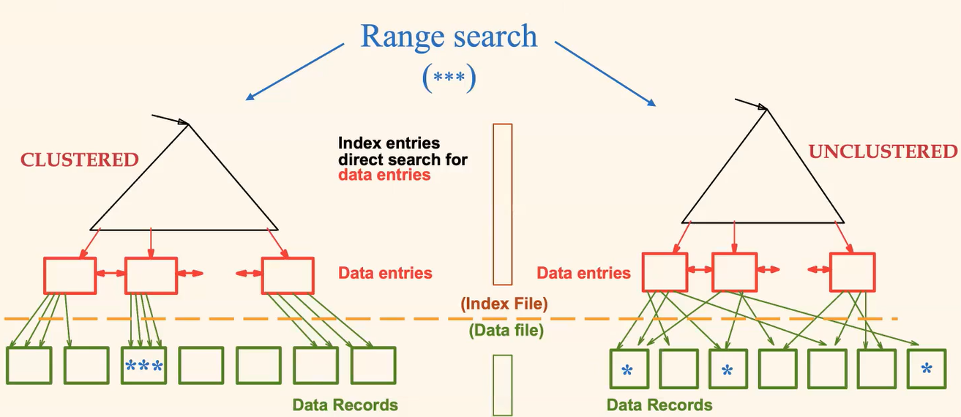

Syntax

CREATE [UNIQUE] INDEX *name* ON *table* [USING *method*]

method = btree/hash/gist/gin, default is btree

Ex. CREATE UNIQUE INDEX title_idx ON films(title)

### ISAM Operations (Indexed sequential access method)

Def

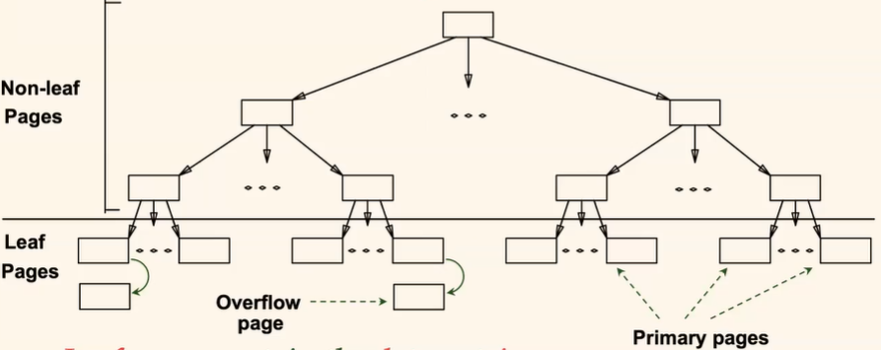

File Creation (leaf data pages first, then index page, then overflow page)

Index entries = <search key value, page id>

Search = log_f(N) where F = # entries/index page, N = # leaf pages

Insert = find leaf data entry and put entry there

Delete = find and remove entry from leaf

Ex

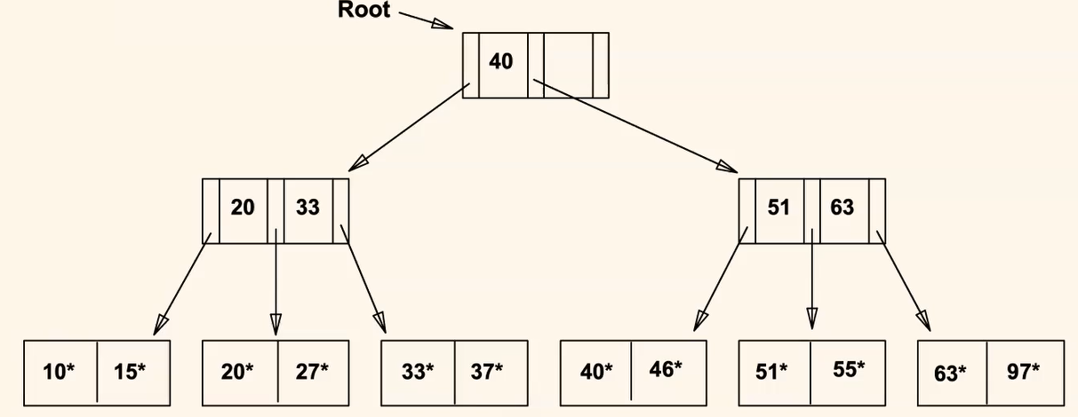

insert 23, 48, 41, 42

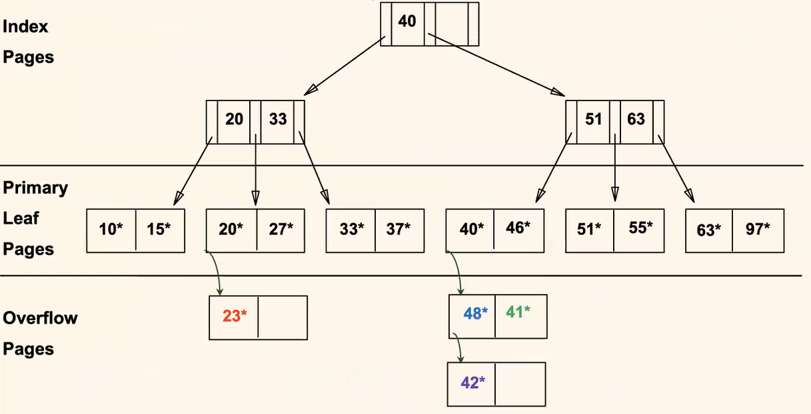

delete 42, 51, 97

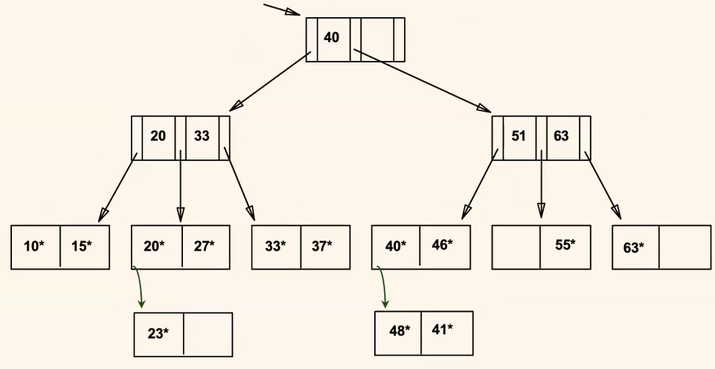

* 51 is not in the leaf, but still in the index level

### B+ Trees

Def

Insert/delete at log_F(N) cost ⇐ height balanced (F=fanout, N = # leaf)

Minimum 50% occupancy (except for root)

each node is at least half full. d <= m <= 2d entries

d = order of the B+ tree

Supports equality and range-search efficiently (find starting point by search, and scan the rest)

Insert:

find correct leaf by searching for new K

put K in leaf L.

If L was full ⇒ split L into two, distribute evenly, and **copy up**

Insert new index entry to its parent

To borrow in an index, redistribute evenly including the parent key ⇒ update parent key (rotate

To split an index node, distribute evenly and **push up** the middle key to its parent

Root split ⇒ increase its height

tree growth = get wider or get one level taller at top

Ex. insert 8

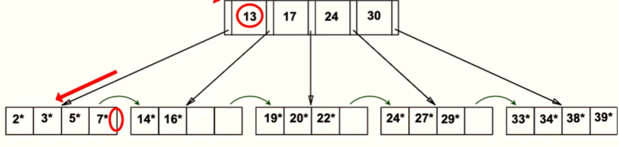

2*, 3*, 5*, 7*, 8* ⇒ 5* is copied up

5, 13, 17, 24, 30 ⇒ 17 is pushed up

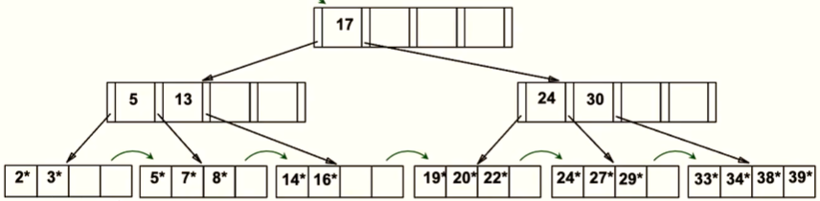

Delete (no need to update index if leftmost data changes)

find leaf L with entry K

remove the entry

If L < d (half full), borrow from sibling, redistribute, **update** parent

If redistribution fails, merge L and sibling, **delete** from parent

Merge at root might decrease the height

Ex. delete 19, 20



borrow. 22*, 24*, 27*, 29* ⇒ update index by **copying up** 27

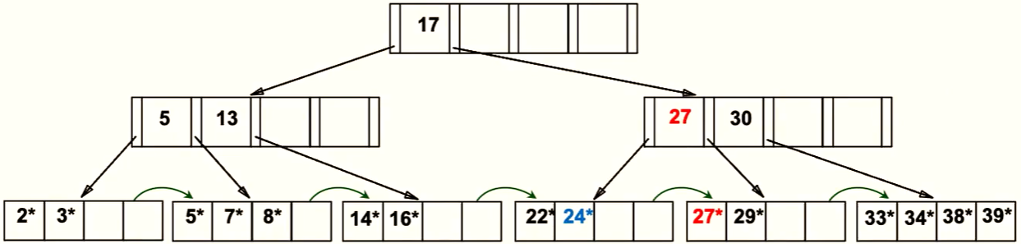

delete 24 ⇒ merge to be 22*, 27*, 29* ⇒ delete 27 in parent

delete 27 in index ⇒ merge 5, 13, 17, 30

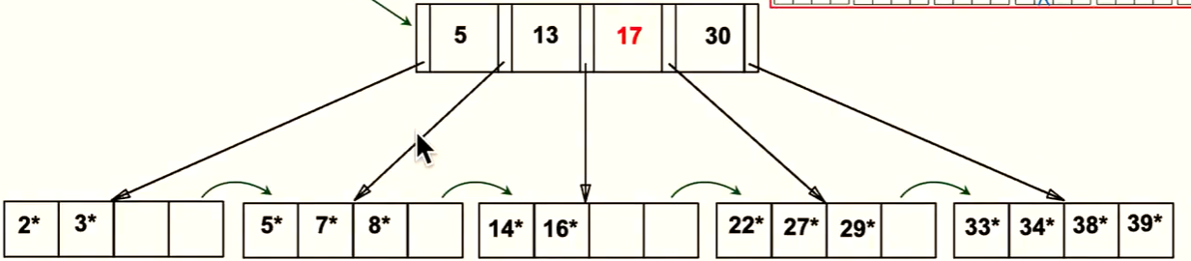

Ex. delete 24 in a different tree

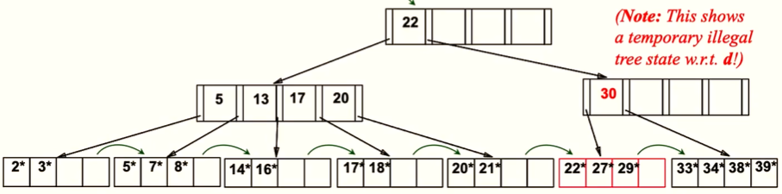

borrow 5, 13, 17, 20, 22, 30 ⇒ parent key becomes 17

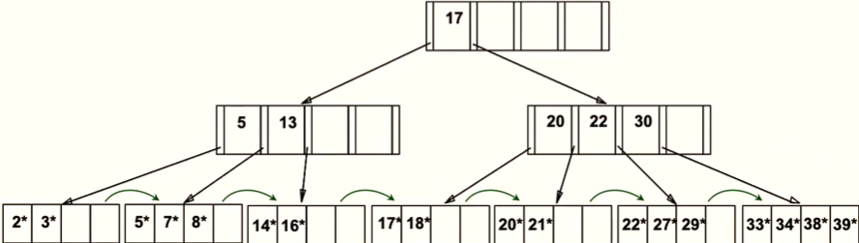

* Bulk loading: sort data entries. index entry, initialize leaf nodes to be half full, insert nodes in order ⇒ only fills and splits the index page
* Index pages usually hold more entries than leaf pages
* Variable-sized records (size might differ for different index)

### Hash-based indexes

Def.

fast for equality selection, cannot support range search

static and dynamic hashing exists

Static Hashed Indexes

# primary pages fixed, allocate sequentially, never deallocate, overflow if needed

h(k) mod N = page to store k (N = # of pages)

might cause unbalanced hash table ⇒ costly to search

FYI

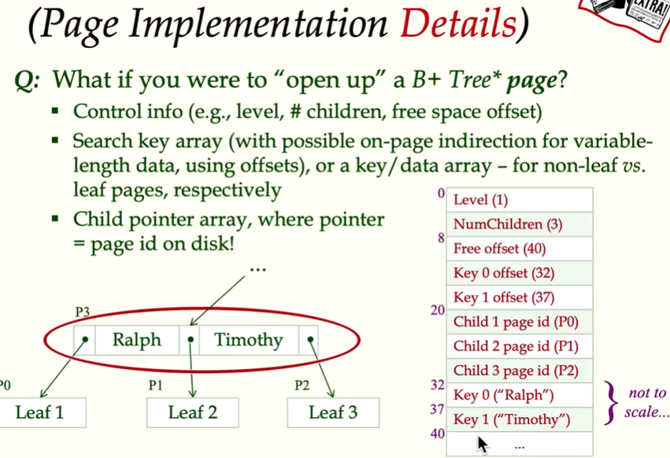

Ex.Alternative 1 is primary index, 2 and 3 are secondary index

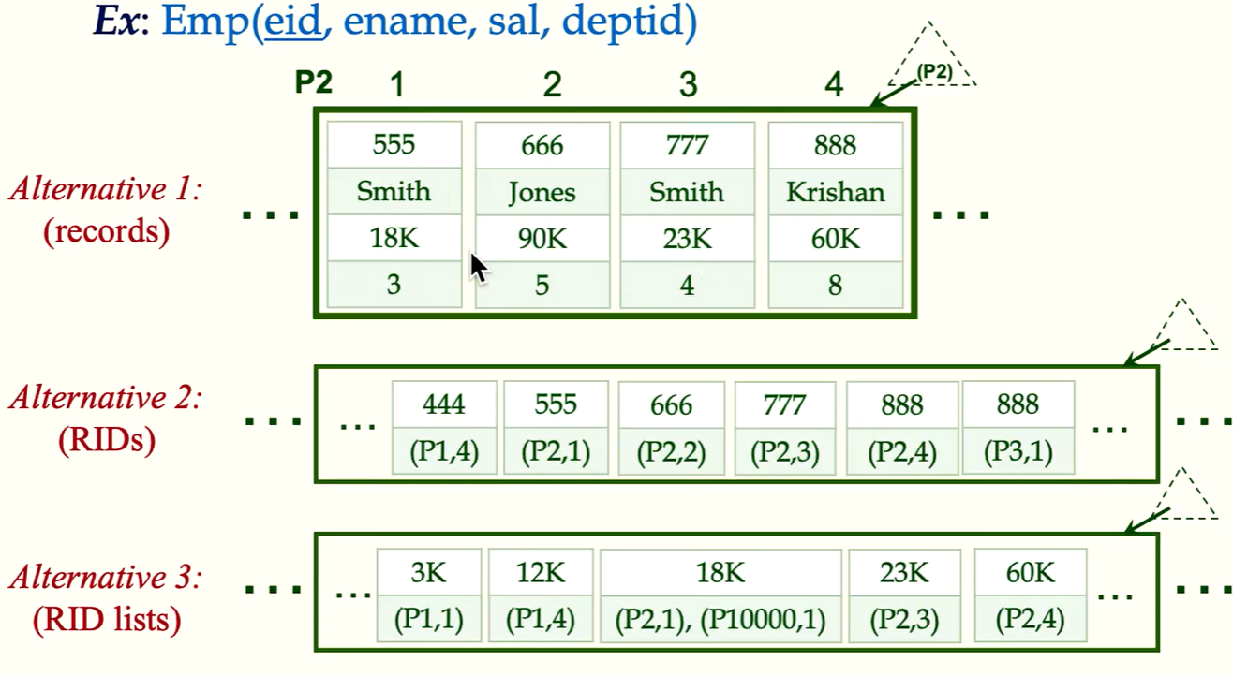

Leaf page alternatives (using primary keys instead of record ids) depends on the system you are using

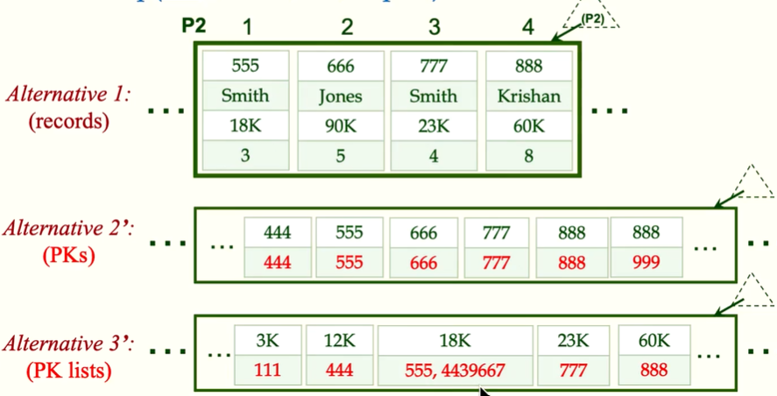

## Physical DB Design

### Understand the workload

Query workload:

which relations

attributes retrieved

how selective are those conditions (attributes in selection/join)

Update

how selective are those conditions (attributes in selection/join)

type of update (insert/delete/update) and affected attributes

### Choice of Indexes

Most important query - if adding an index improves the query plan ⇒ create it

Trade-off - index slows down the updates and requires disk space

Index Selection Guide:

attributes in WHERE are candidates for index

extract match ⇒ hash index

range query ⇒ B+ tree index

clustering is very good for range queries, may help equality queries with duplicate values

several conditions in WHERE ⇒ multi-attribute search keys

order of attributes in key matters for range queries

index-only strategies ⇒ data clustering is not important

Choose index that benefit as MANY queries as possible

* query access small portion of data ⇒ index will help a lot

Ex. SELECT E.dno FROM Emp E WHERE E.age > 40

B+tree index on E.age. However, if almost all employees are over 40 year old, this query is not selective and not worth indexing

Ex. SELECT E.dno FROM Emp E WHERE E.hobby = ‘stamps’

Equality queries & duplicates ⇒ clustering on E.hobby will help

Index with Composite Search Keys

Equality query: age = 20 AND salary = 75

Intersection: use index on age and index on salary separately to find the data record. and find intersection of both result

Composite index: <age, sal> and <sal, age> both works

Range query:

(20<age < 30 AND sal > 10) clustered B+ tree on <age, sal> or <sal, age>

(age = 30 AND sal > 10) clustered <age, sal> is better than <sal, age>

* composite index are larger and updated more often

### Index-only Query Plan

some queries ban be answered without retrieving from relations ⇒ index

Index on <E.dno>:

SELECT E.dno, COUNT(*)

FROM Emp E

GROUP BY E.dno

B+ tree index on <E.dno, E.sal>

SELECT E.dno, MIN(E.sal)

FROM Emp E

GROUP BY E.dno

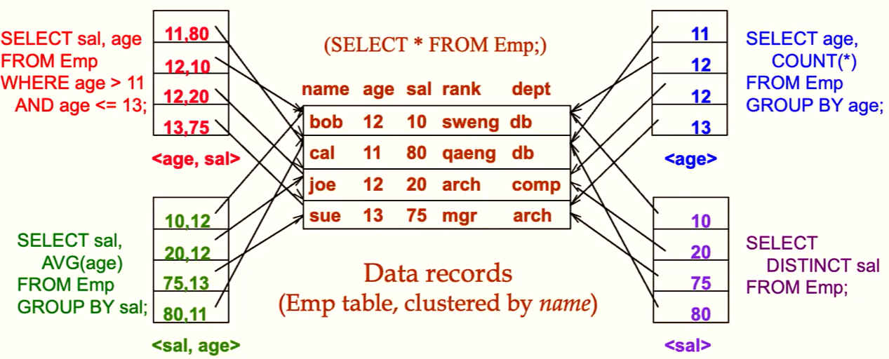

Joins

Index Nested Loop Join (INLJ)

for each outer table, use its join attribute value to probe inner table for tuples to join it with

Indexing the INNER table’s join column will help

Good to be clustered if the join column is NOT primary key of inner table

Sort-Merge Join (SMJ)

sort outer and inner tables on join attribute value and scan them to match tuples

Clustered B+ tree on both join columns

Hash Join (HJ)

hash one table, probe with the other

indexing not needed

Ex.

SELECT E.ename, D.mgr

FROM Emp E, Dept D

WHERE D.dname = “Toy” AND E.dno = D.dno

**Index on D.dname supports “Toy” selection**

**Index on E.dno allows us to fetch matching**

**Index on D.dno is NOT needed**

* + IF adds E.age = 25, then we can choose to index on D.dname or on E.age. If both exists, the database will choose the cheaper one. Otherwise, the database will choose whatever index exists.
  + **Clustering helps INNER tuple a lot ⇒ E.dno should be clustered**

Ex.

SELECT E.ename, D.mgr

FROM Emp E, Dept D

WHERE E.sal BETWEEN 10000 AND 20000 AND E.hobby = ‘Stamps’ AND E.dno = D.dno

Emp E is more selective ⇒ outer table ⇒ index on inner table is D.dno

For E, B+ tree on E.sal OR index on E.hobby depending on which one is more selective

Ex.

SELECT E.ename, D.mgr

FROM Emp E, Dept D

WHERE E.hobby = ‘Stamps’ AND E.dno = D.dno

If most E collect stamps, sort-merge join may be worth considering.Clustered index on D.dno will help

* + Clustering is useful whenever many tuples are expected for one value or a range of values

### Tuning Conceptual Schema

Ex. Denormalization for performance

for the following tables

Suppliers(sid, snake, address…)

Parts(pid, pname, size, listPrice…)

Stock(sid, pid, price, quantity)

a large portion of workload is the following

SELECT s.sid, s.sname, avg(t.price)  
FROM Suppliers S, Stock T

WHERE s.sid = t.sid

GROUP BY s.sid, s.sname

consider add sname to Stock

Vertical Partitioning: table with many columns (not all of which are of interest to all queries)

Ex. Emp(eno, email, name, address, salary, age, dno)

Employee communications queries (eno, email, name, address)

Employee compensation queries (eno, salary, age)

Employee department queries (eno, dno)

Can improve the performance of full scan

Horizontal Partitioning: (less common) only partial rows are used by different users

One approach is to create a clustered B+ tree index

Another approach is to replace relation with multiple relations with same column for different users

Union all new relations = original relation

We can create multiple relations and create a view to view all rows of original relation

OR, we can create one relation and create multiple views for different users

Query Tuning

query runs too slow ⇒ rebuild index OR table statistics are too old

DBMS may not use the plan you had

with arithmetic or LIKE expressions

with OR conditions

with NULL values

lack of advanced evaluation features (index-only strategies or certain join methods, or poor size estimation)

Check the query plan and rewrite

Miscellany for Query Tuning

Minimize the use of DISTINCT (if duplicates are acceptable or it’s already duplicate-free)

DBMS’s use of indexes when using arithmetic expressions

Ex. E.age = 2*D.age can benefit from an index on E.age, but won’t benefit from index on D.age

## Semi-structural Data Structure

## NoSQL (not only SQL)

Background:

good performance + low flexibility → key+value → column family → document → graph → low performance + high flexibility

NewSQL?

NoSQL is more scrabble and good performance in big data

NoSQL Data (Json-based)

Nesting complex object

Self-describing

Naturalness of fluidity

Ex. Collection(Orders){

‘id’: “123”,

“customer”:{

“custName”: “Fred”,

“custCity”: “LA”

}

“total”:25,

“Items”:[

{“product-sku”:401,

“qty”:2,

“price”: 9.99

},

{“product-sku”:544,

“qty”:1,

“price”: 3.99

}

]

}

NoSQL Object no schema

no mandatory data. If it doesn’t exist, it’s missing

no data type for every “column” if not specified

* Be aware of the possible inconsistencies in fields

SQL++ is just like SQL

returns a list of Json objects (**unordered** object)

SQL usually provides informative errors

Do you mean ‘raging’ bt ‘rating’?. SQL++ only tells you it doesn’t exist

Do you mean c.rating by rating? SQL: it’s ambiguous query

* in NoSQL might cause collision in the field names

Json can only have unique names in an object

SELECT VALUE field (skill the wrapper of Json)

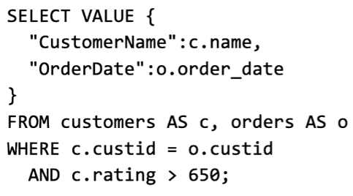

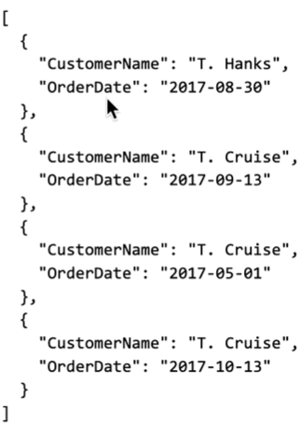

Ex. get the names of customers with highest rating

SQL Way

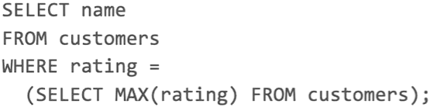

NoSQL Way (with **[0]**)

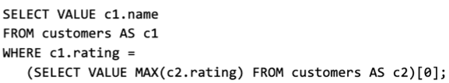

### Nesting

SELECT VALUE with nested

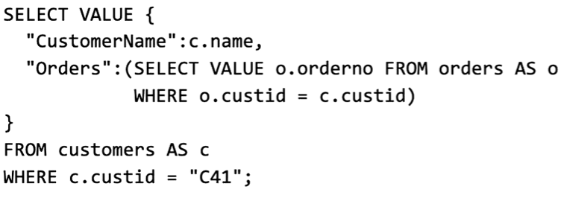

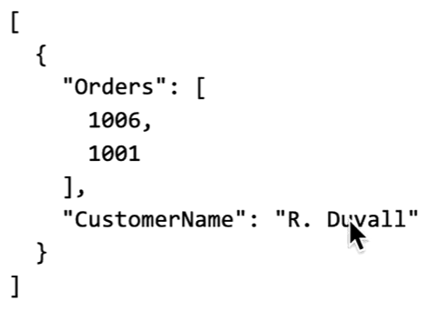

Unnesting

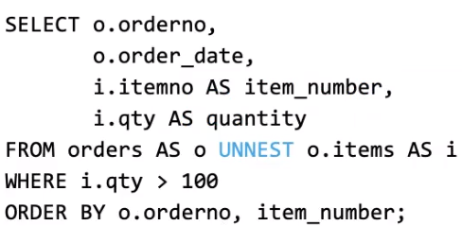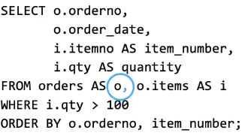

### Quantification

(EXISTS = SOME, division = EVERY)

Ex. get customer id whose some/all orders satisfies its price >=25

SELECT DISTINCT VALUE o.custid

FROM orders AS o

WHERE **SOME/EVERY** i IN o.items SATISFIES i.price >= 25

Ex. every order >= 25 for sure and must contain at least one order

SELECT DISTINCT VALUE o.custid

FROM orders AS o

WHERE array_count(o.items) > 0 AND **EVERY** i IN o.items SATISFIES i.price >= 25

* For orders without any items, they also satisfy the condition, so we need to specify ***array_count(o.items) > 0*** OR ***SOME AND EVERY***instead of ***EVERY*** to exclude them.

Ex. get customers who bought item(s) with price >= 25

SELECT VALUE c

FROM customers AS c

WHERE c.custid IN(

SELECT DISTINCT VALUE o.custid

FROM orders AS o

WHERE SOME i IN o.items SATISFIES i.price >= 25

)

Grouping

Ex. SQL

SELECT c.address.city, count(*) AS cnt

FROM customers AS c, orders AS o

WHERE c.custid = o.custid

GROUP BY c.address.city

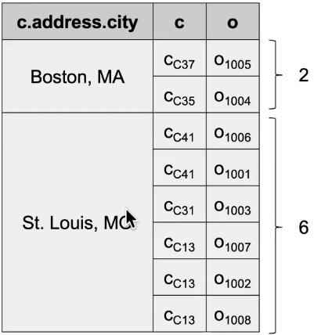

Ex.

SELECT c.address.city, g

FROM customers AS c, orders AS o

WHERE c.custid = o.custid

GROUP BY c.address.city GROUP AS g

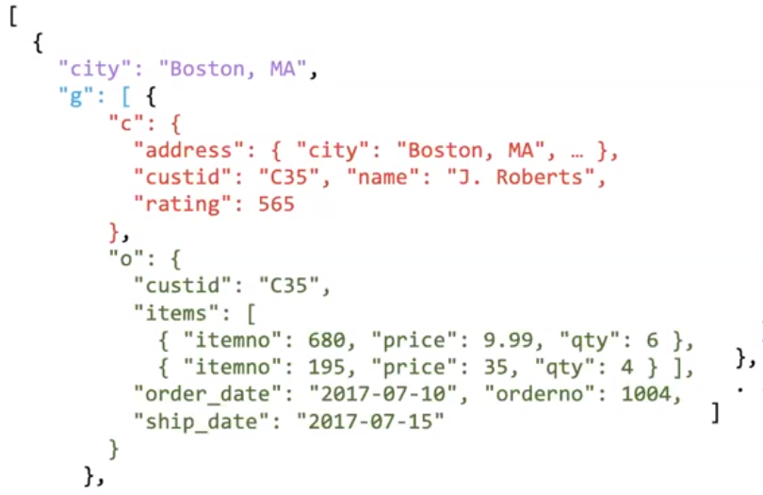

Ex. grouping and aggregation

SELECT c.address.city, array_count(g) as cnt

FROM customers AS c, orders AS o

WHERE c.custid = o.custid

GROUP BY c.address.city GROUP AS g

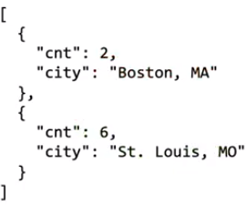

Aggregation

Ex. NoSQL aggregation on o.items

SELECT c.name, array_count(o.items) as order_size

FROM customers AS c, orders AS o

WHERE c.custid = o.custid

ORDER BY order_size DESC

LIMIT 3

Ex. max

array_max((SELECT VALUE rating FROM customers))

### Missing Information

data IS MISSING (no header)

data IS NULL (column header with NULL value)

data is UNKNOWN (data is missing or NULL)

Ex. select missing data will not appear

SELECT o.orderno, o.order_date, o.ship_date, o.custid

FROM orders o

WHERE o.ship_date IS MISSING

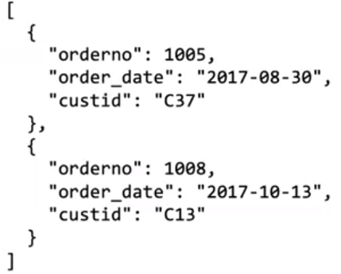

Ex.

SELECT VALUE {

“orderno” : o.orderno,

“order_date”: o.order_date,

“ship_date”:

CASE

WHEN o.ship_date IS MISSING THEN “TBD”

ELSE o.ship_date

END,

“custid”: o.custid

}

FROM orders o

ORDER BY ship_date DESC

## Advanced SQL Analysis

### Ranking in SQL (order by)

Ex. student_grades(ID, GPA)

SELECT ID, rank() over (order by GPA desc) as s_rank

FROM student_grades

**ORDER BY s_rank**

dense_rank = ranking without gap

Ex. 2 students have the same top GPA with rank = 1

next student, dense_rank() = 2

next student, rank() = 3

Partition Ranking

multiple OVER clauses can be in one select clause

ranking OVER is done after applying grouping/aggregation

can be used to find top-N results

Ex. select * from (

select ID, rank() over (order by GPA desc) as s_rank

)

where s_rank >= 3

* LIMIT is arbitrary and doesn’t find the top 3 things (Questions!! if we order by s_rank then limit 3) and this way allows partitioning

Ex. group by dept_name and rank by GPA (multiple rank 1s for different partition value)

SELECT ID, dept_name, rank() over (partition by dept_name order by GPA desc) as dept_rank

FROM dept_grades

ORDER BY dept_name, dept_rank

* rank over (partition ) will display rank inside the partition group

NULL first/last

SELECT ID, rank() over (order by GPA desc NULLS last) AS s_rank

FROM student_grades

Other ranking functions

* row_number non-deterministic in presence of duplicates

select ID, row_number() over (order by GPA desc) as s_row

from student_grades

order by s_row

* cume_dist (cumulative distribution) fraction of tuples with preceding values
* percent_rank (within partition if partitioning is done)
* ntile(n) divide tuples equally into n buckets (n is constant)

select ID, ntile(4) over (order by GPA desc) as quartile

from student_grades

### Windowing in SQL

To annotate tuples based on related context

Ex. everything up the current tuple or nearby tuples

To smooth out random variation

Ex. moving average: given sales values for each data, calculate average of that day, previous day and next day

Window specification

Ex. daily_sales(date, value) (bold text = current row +/- 1 row)

select date, avg(value) over (order by date rows between **1 preceding and 1 following**) as daily

from daily_sales

To get data from beginning to current

rows unbounded preceding

rows between unbounded preceding and current

range between 10 preceding and current row

rows with values [current row - 10, current row]

Windowing with partitions

organize the data by partition value

Ex. transaction(account_number, date_time, value)

select account_number, date_time, sum(value) over

(partition by account_number

order by date_time

rows unbounded preceding

) as balance

from transaction

order by account_number, date_time

## Online Analytical Processing (OLAP)

Hierarchy on dimension attributes (for different level of details)

Ex. location – city – state – county – region

Multi-dimensional data = data that can be modeled as …

measure attributes (ex. temperature, price, quantity)

dimension attributes (ex. item_name, color of a sales relation)

### Cross-Tab (Pivot Table)

2 dimension attributes for row and column headers

* for n dimensions, we have n headers for n attributes

the other (non-tabulated dimension attributes) are listed above the table

cell value = sum of the measure attributes

Ex. sales(item_name, color, clothes_size, quantity)

non-SQL table

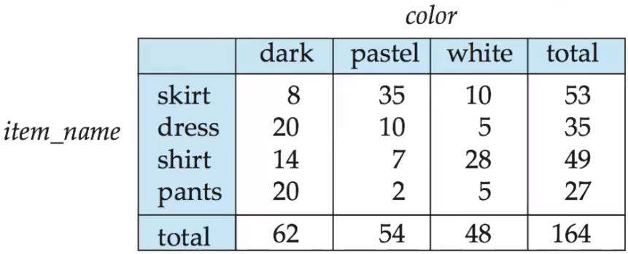

### Cube to generate cross-tab

SQL table

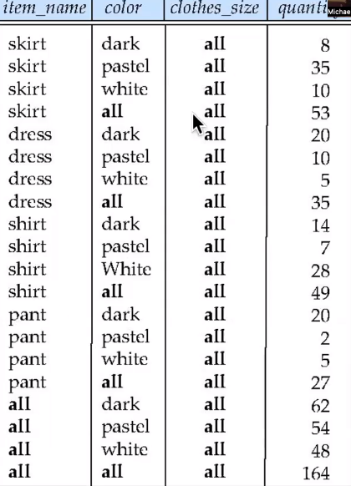

select item_name, color, clothes_size, sum(quantity)

from sales

group by **cube**(item_name, color, clothes_size_

order by item_name, color, clothes_size

⇒ 8 groupings

{(item_name, color, clothese_size),

(item_name, clothese_size),

(item_name, color),

(clothese_size, color),

(item_name),

(clothese_size),

(color),

()

}

Grouping to get cell value (1 if value is null representing all. 0 other cases)

select item_name, color, clothes_size, sum(quantity),

grouping(item_name) as item_name_flag,

grouping(color) as color_flag,

grouping(clothes_size) as size_flag

from sales

group by cube(item_name, color, clothes_size)

### Coalesce() in select to replace nulls with a value

select coalesce(item_name, “all”) as item_name

from sales…

### Rollup to generate union on every prefix (used for levels of hierarchy

select item_name, color, clothes_size, sum(quantity)

from sales

group by **rollup**(item_name, color, clothes_size_

⇒ 4 groupings

{(item_name, color, clothese_size),

(item_name, color),

(item_name),

()

}

## Transactions

Shivani Gupta [shivani.gupta@couchbase.com](mailto:shivani.gupta@couchbase.com)

Def = unit of program execution with following properties (ACID)

Atomicity - cannot be partially executed (All or Nothing).

Durability - transaction has completed ⇒ database should persist even if there are failures

Consistency - can be temporarily inconsistent during transaction, but MUST be consistent when transaction completes

Isolation - concurrent execution of multiple transactions (no middle status is accessed by other transactions)

Syntax

START TRANSACTION;

COMMIT/ROLLBACK; (rollback = abort)

Concurrent executions to allow more usage of the system

concurrency control schemas to achieve isolation

Scheduling transactions = instructions of concurrent transactions

serial schedule = does NOT interleave the actions of different transactions

equivalent schedule =

serializable schedule

Ex. transfer $50 from A to B and transfer 10% of the balance from A to B

serial schedule (switching T1 and T2 also ensures consistency)

T1:

read(A) ⇒ A := A - 50 ⇒ write(A)

read(B) ⇒ B := B + 50 ⇒ write(B)

commit

T2:

read(A) ⇒ tmp = A*0.1 ⇒ A = A - tmp ⇒ write(A)

read(B) ⇒ B := B + tmp ⇒ write(B)

commit

equivalent schedule (if first T1 doesn’t write(A) ⇒ not consistent)

T1

read(A) ⇒ A = A - 50 ⇒ write(A)

T2

read(A) ⇒ tmp = A*0.1 ⇒ A = A - tmp ⇒ write(A)

T1

read(B) ⇒ B = B + 50 ⇒ write(B)

T2

read(B) ⇒ B = B + tmp ⇒ write(B)

commit

Anomalies with interleaved Execution

reading uncommitted data (dirty reads)

T1 R(A),**W(A)** R(B),W(B), **Abort**

T2 **R(A)**,W(A),C

unrepeatable reads

T1 **R(A)** **R(A)**,W(A),C

T2 R(A),**W(A)**,C

overwriting uncommitted data

T1 W(A) **W(B)**, C

T2 **W(A)**, W(B), C

Isolation level in SQL-92

Serializable - default

repeatable read & dirty read - only committed records to be read

read uncommitted - even uncommitted read may be read

### Implementation of Isolation level

Ways

Lock (shared S vs exclusive X locks)

only can be shared if two transactions can use shared locks

transaction of timestamps (read timestamp, write timestamp)

multiple versions of each data item (read from a snapshot of DB)

Lock-based protocols

2PL Protocols (2-phase locking)

growing phase (only obtain locks)

shrinking phase (only release locks)

* strict 2PL release locks only at commit or abort time - simplities transaction aborts

Ex. reading uncommitted data (dirty reads)

T1 R(A) SL,**W(A)** XL R(B),W(B), **Abort**

T2 **~~R(A)~~**~~,W(A),C~~

cannot access A because there is a XL (exclusive lock)

Ex. unrepeatable reads

T1 **R(A)** SL **R(A)**,~~W(A),C~~

T2 R(A) SL,**~~W(A)~~**~~,C~~

both cannot W(A) because 2 transactions have SL in A ⇒ dead lock ⇒ wait for the system to kill one of the SL

Ex. overwriting uncommitted data

T1 W(A) XL **W(B)**, C

T2 **~~W(A)~~**, W(B), C

XL ⇒ cannot access A

Abort a transaction

abort Ti ⇒ all actions of Ti must be undone

if Tj reads a value written by Ti ⇒ Tj must also be aborted

avoid cascading aborts by releasing transaction’s locks only at commit time (strict 2PL protocol)

if Ti writes an object, Tj can read it only after Ti commits

to undo the actions, DBMS keeps a log where every writes are recorded

### Recovery

Failure Types

Transaction failure

logical errors ⇐ internal error condition

system errors: terminate an active transaction (deadlock)

System crash ⇐ power failure or other hardware/software failure

fail-stop assumption (It is assumed that a system crash does not have any effect on the data stored in the non-volatile storage)

disk failure ⇒ destroys all/parts of disk storage

Recovery algorithm has two parts

actions taken during normal transaction to store information for recovery

actions taken after a failure to recover the DB contents to a safe state (with atomicity, consistency, durability)

Transaction Log

Ti writes an object (log record old + new values)

Ti commits/aborts (log record noting the outcome)

All log related activities are transparently taken care of by DBMS

Checkpoints

output all log records currently in main memory onto stable storage

output all modifies buffer blocks to disk

write a log record <checkpoint L>

all updates are stopped while checkpointing

Ex.

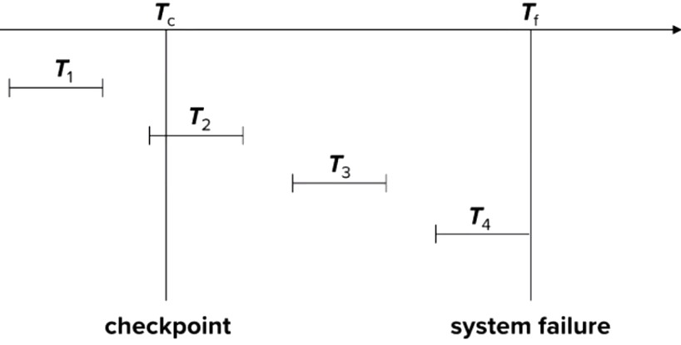

T1 is ignored, T2 and T3 redone, T4 undone (because T4 is not completed yet before failure)

Recover from a Crash (ARIES three-phase recovery algorithm)

Analysis = scan logs to identify affected transactions and memory

Redo any updates that were completed but not captured to dirty pages

Undo writes of all Xacts that were active at crash (partially completed)

## Using Transactions

Access Mode

READ ONLY (no write)

READ WRITE (default)

Isolation level

READ UNCOMMITTED (can see dirty data)

READ COMMITTED (can NOT see dirty data)

REPEATABLE READ (re-read get same result) - second highest

SERIALIZABLE (no concurrency worries) - highest

* choosing isolation level ⇒ programming model
* not all levels are supported for different systems
* Default isolation and highest isolation level varies for systems

## Dataframes

Ex. sailors = pandas.read_csv(“path/of/csv”)

sailors.dtype ⇒ data type. if NaNN in row, data object is returned

sailors.describe() ⇒ for each numeric column, display statistics like mean, min…

selections = get rows

sailors.head(3) ⇒ first three rows of sailors

sailors.tail(3) ⇒ last three rows of sailors

sailors[10:12] ⇒ get row 10 and row 11 (exclude 12)

sailors[saliors.age < 10] ⇒ get rows (with all columns) where age is less than 10

sailors[sailors.major == “CS” | sailors.major == “EE”]

sailors.assign(dogage = sailors.age / 7)

⇒ create the view with a new column whose value = age/7

projections = get columns

sailors[“sname”] ⇒ get column with this column name

sailors[[“sname”, “ratings”]] ⇒ get columns with name

joins

pandas.merge(reserves, boats, left_on=”bid”, right_on=”bid”)

pandas.merge(reserves, boats, on=”bid”, how=”left”) can be outer or inner

unions

moreboats = pandas.read_json(...)

boats = pandas.concat([boats, moreboats], ignore_index = True)

grouping

bymajor = sailors.groupby(“major”) ⇒ returns group object

bymajor.size() ⇒ return size of each group

bymajor.count() ⇒ return size of each group for the other columns (sid, rating…)

bymajor.rating.max() ⇒ return max rating for each group

bymajor.max()[[“rating”, “age”]] ⇒ return multiple max for each group

bymajor.agg({‘rating’:[‘min’, ‘max’], ‘age’: [‘count’, ‘mean’, ‘std’]})

⇒ general purpose aggregate method. For rating, get min and max. For age, get count, mean and std.

bymajor.rating.max().sort_values(ascending = False) [:3] ⇒ get top rated group

## ER Diagram Representation Sum

### Attributes

Simple attribute = atomic values, which cannot be divided further.

Composite attribute made of multiple attributes

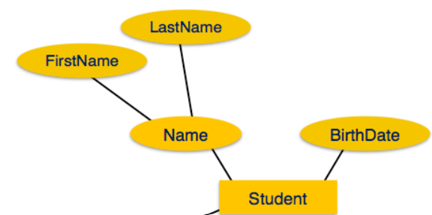

Derived attribute = values are derived from other attributes present in the database.

ex. age can be derived from data_of_birth.



Single-value attribute

Multi-value attribute contains more than one value for one attribute.

ex. a person can have more than one phone number, email_address, etc.

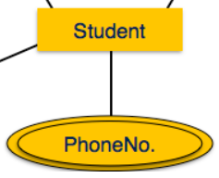

### Total Participation != Weak

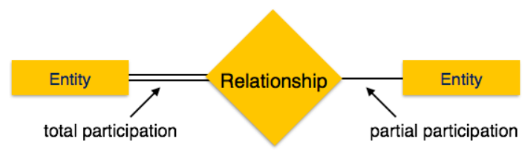

Weak Entity and weak relationship

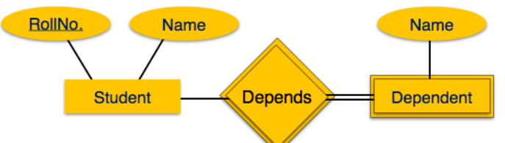

[ Student ] —1— <<Depends>> **—N—** [[ Dependents ]] means at least 1 is mandatory.

Dependens is double-lined because it’s the identifying relationship of the weak entity

PRIMARY KEY (studio_name, crew_number)